FINAL PROJECT – KIRUBA R P (22ITR046) IT – ‘A’

1. Jenkins Pipeline output:

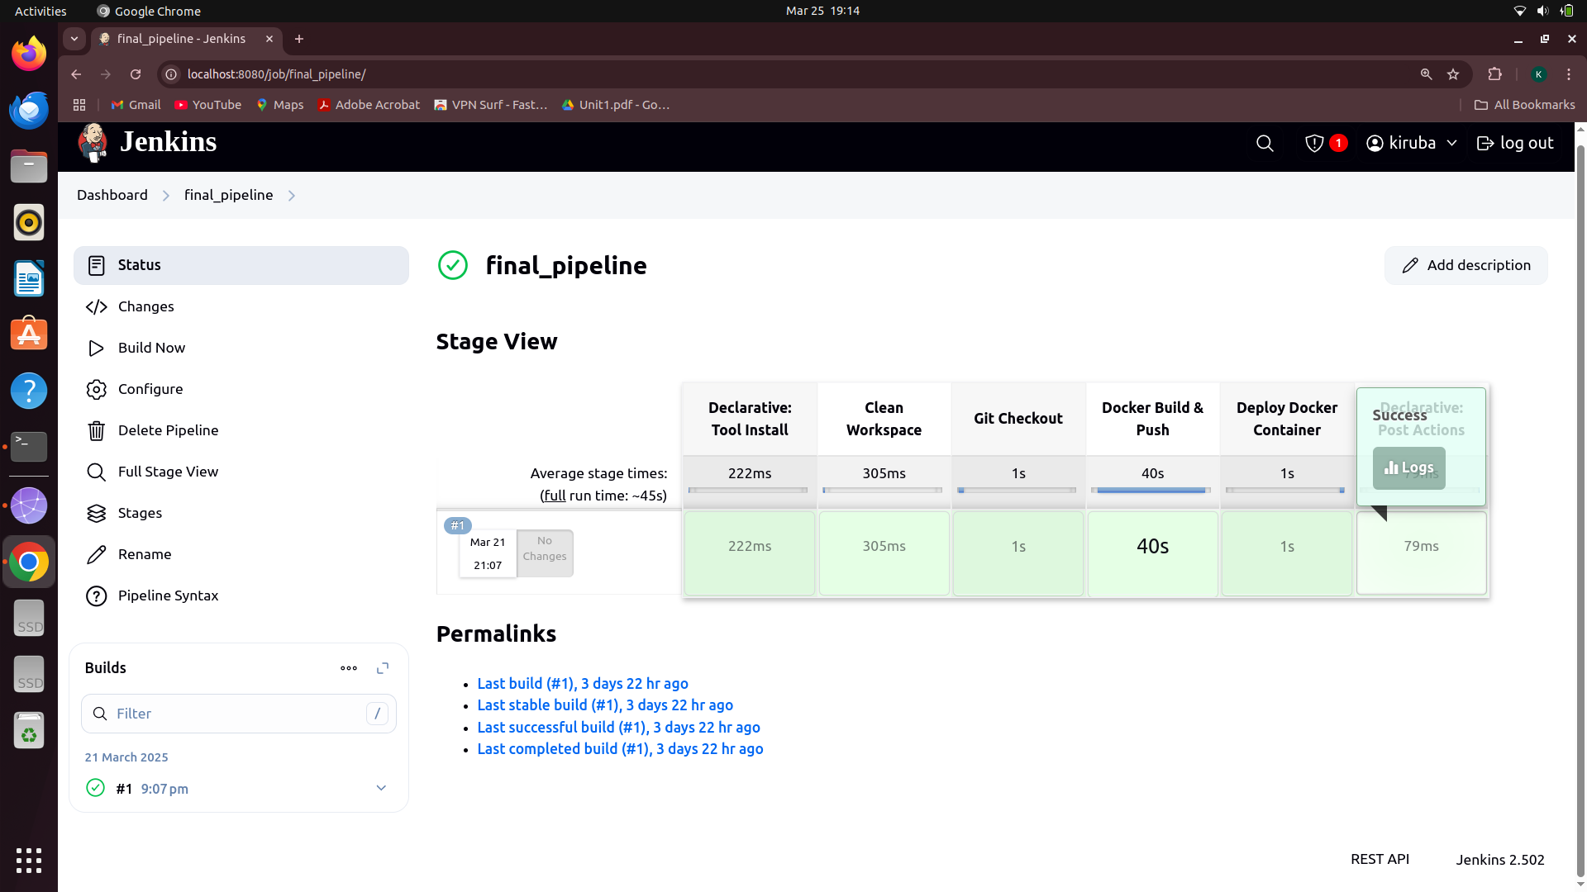
2.Jenkins Console output :

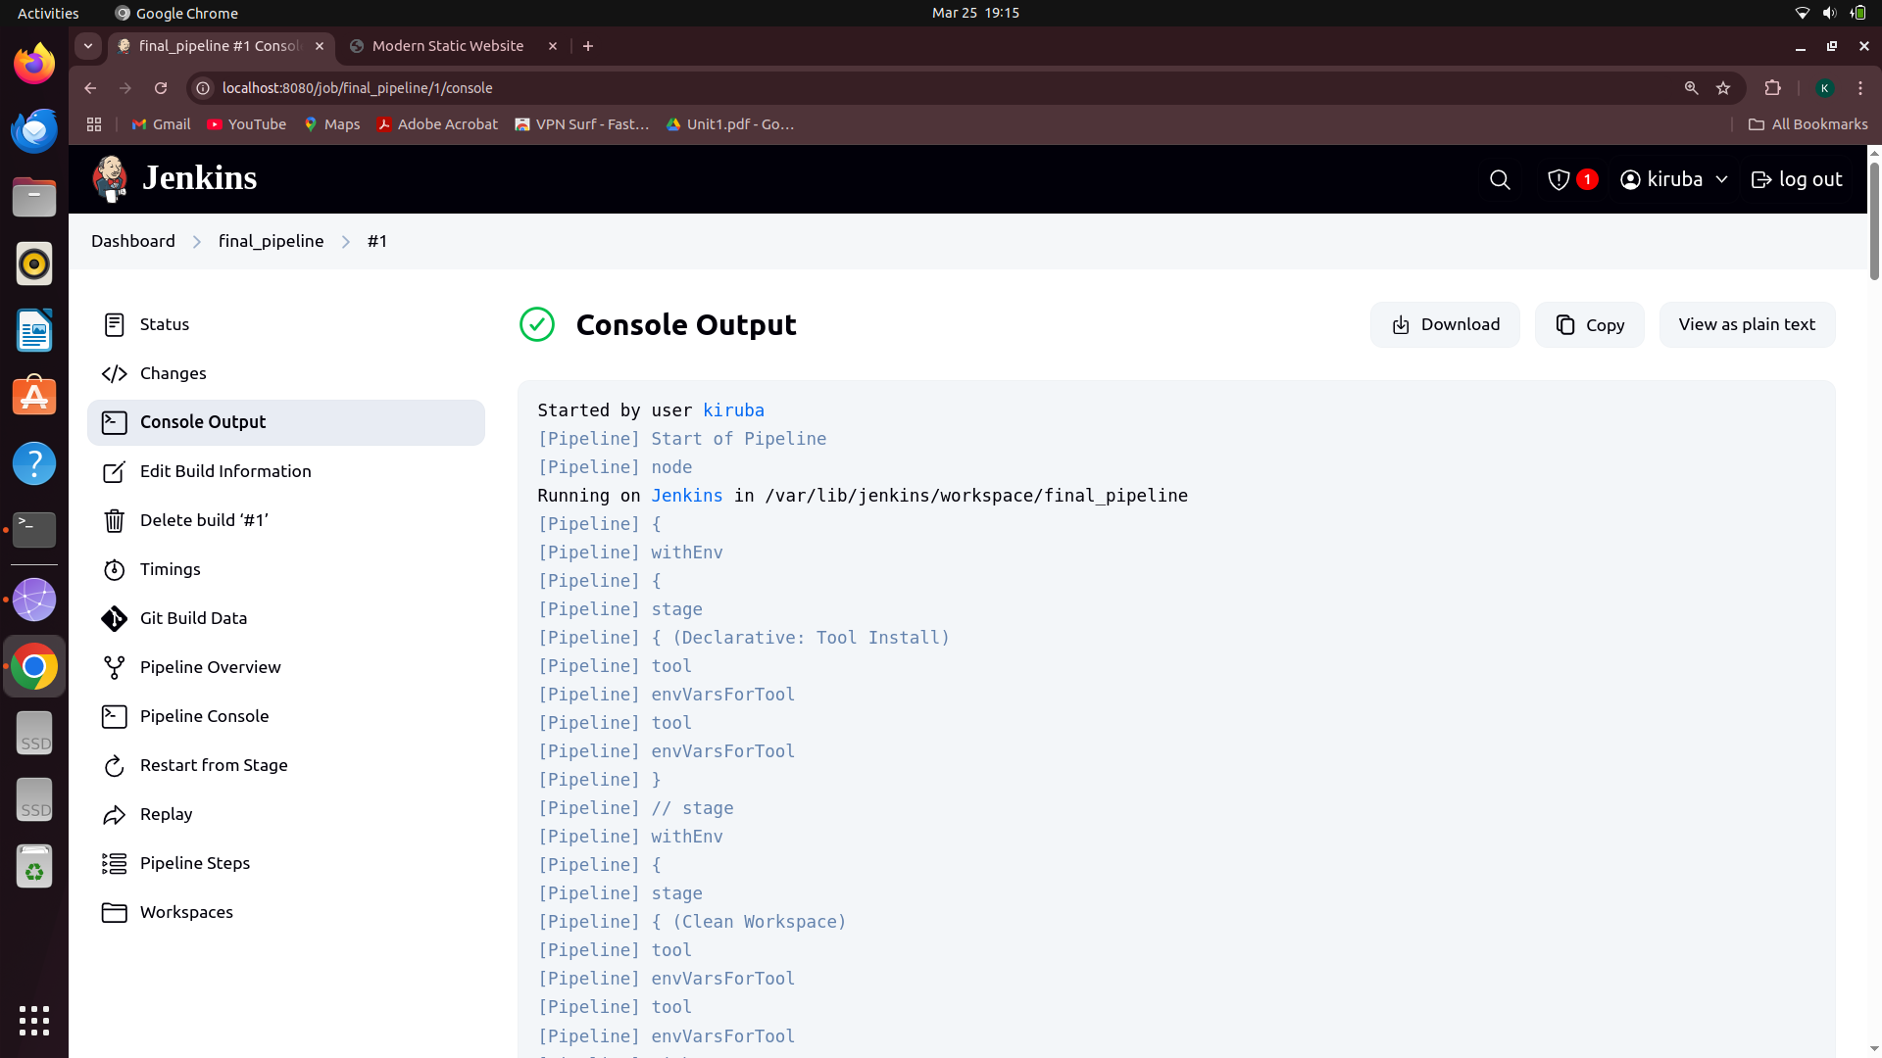

3.Minikube status :

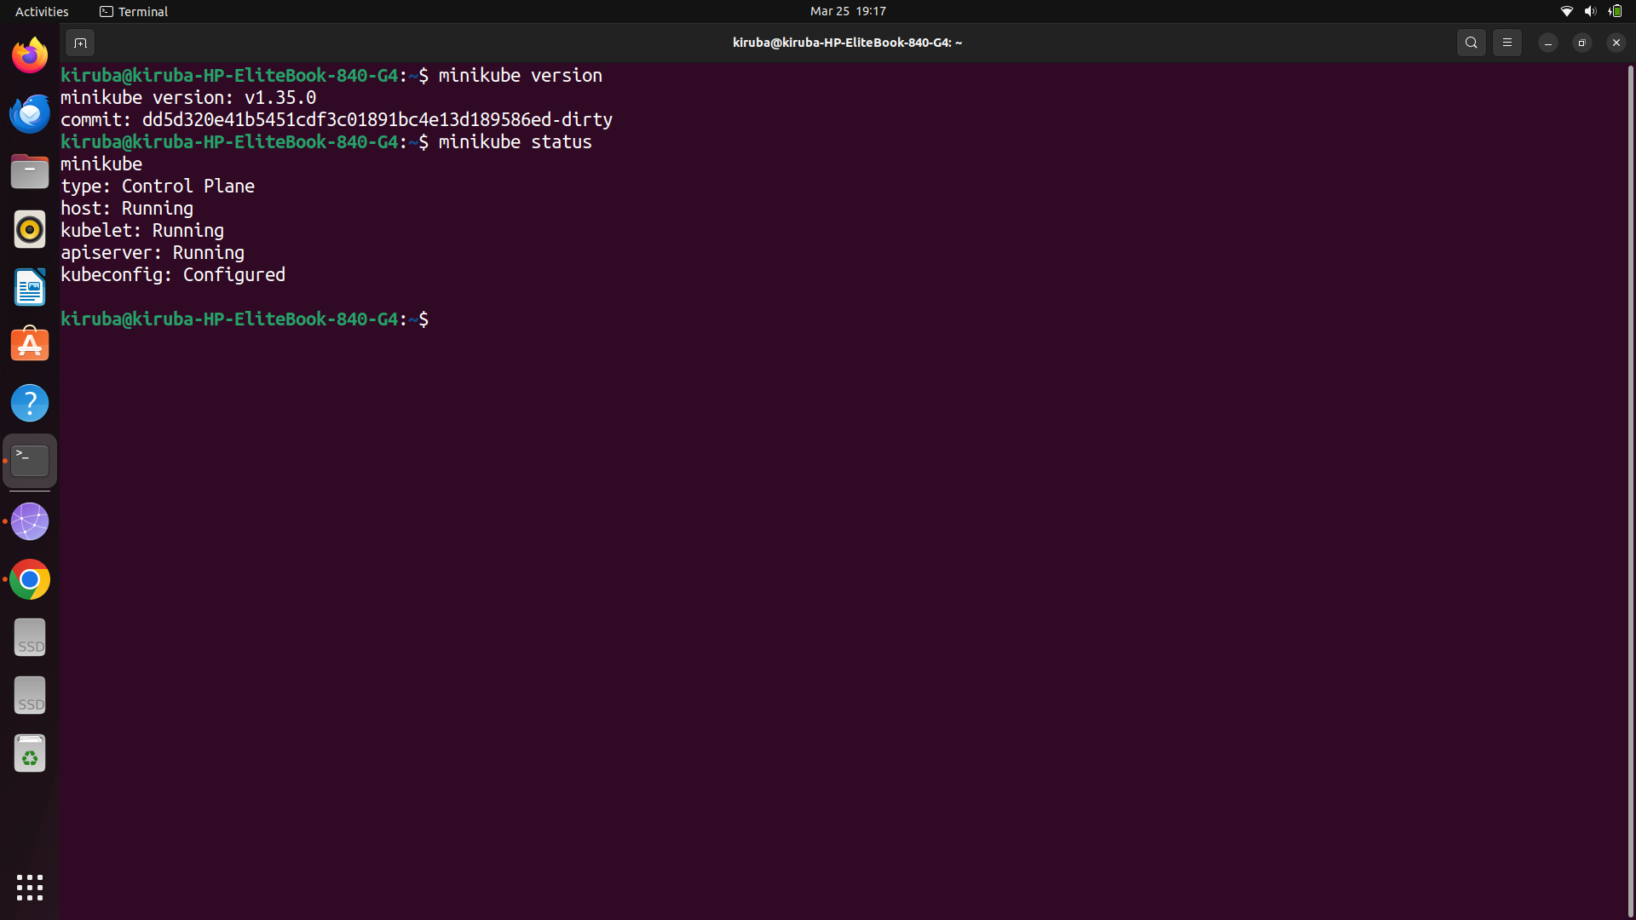

4.Docker Repository :

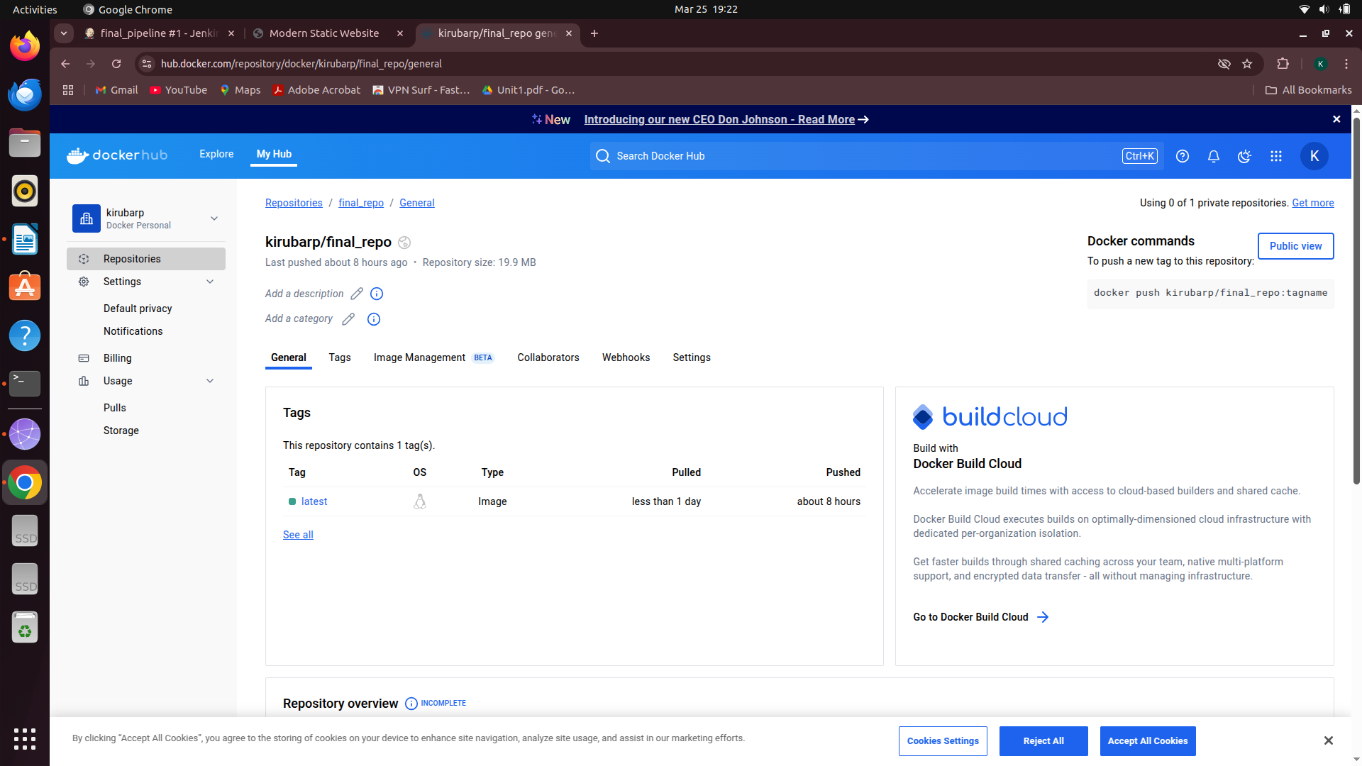

5. Webiste Output :

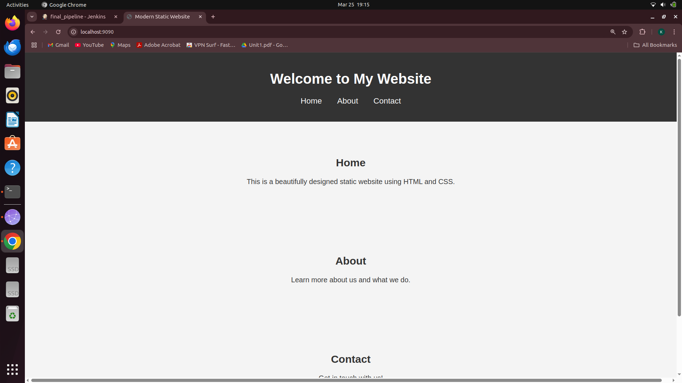
Pipeline script :

pipeline {
agent any
tools {
jdk 'jdk21'
nodejs 'node20'
}

environment {
IMAGE_NAME = "kirubarp/final_repo"
CONTAINER_NAME = "static-website-container"
TAG = "latest"
DEPLOYMENT_FILE = "deployment.yaml"
KUBECONFIG = "/var/lib/jenkins/.kube/config"
}

stages {
stage('Setup Minikube Docker') {
steps {
script {
sh "eval \$(minikube docker-env)"
}
}
}

stage('Clean Workspace') {
steps {
script {
echo "Cleaning workspace..."
deleteDir()
}
}
}

stage('Git Checkout') {
steps {
script {
git branch: 'main',
credentialsId: 'github_seccred',
url: 'https://github.com/Kiruba-Prakasan/final_repo.git'
}
}
}

stage('Docker Build & Push to Minikube') {
steps {
script {
sh "docker build -t ${IMAGE_NAME}:${TAG} ."
}
}
}

stage('Deploy to Minikube') {
steps {
script {
sh "kubectl apply --validate=false -f ${DEPLOYMENT_FILE}"
}
}
}
}

post {
success {
script {
def minikube_ip = sh(script: 'minikube ip', returnStdout: true).trim()
echo "Deployment Successful! Website is live at http://${minikube_ip}:30080"
}
}
failure {
echo "Deployment Failed! Check logs for errors."
}
}
}

